Indicators in the News:
The Urban Institute - Interactive Maps
Web chatter around data is implying we are now experiencing a revolution - a data revolution. While not completely new, data visualization advances could be occurring as a part of the revolution because of their ability to explain real-world problems
We at the EWU’s Community Indicators offices love data visualization and enjoy sharing what we find interesting. This is partly because we know good data visualization can do an excellent job of explaining complexity, as well as making the data a little more fun, too.
The Urban Institute’s Interactive Map website is a great compilation of interactive data visualizations that takes the complex and simplifies the story. For example, most of the maps referenced include data for every county in the U.S., or a designated boundary, such as “Commuting Zones” as offered in the Mapping America’s Futures interactive map. Taking boundaries people are already familiar with (county and state boundaries, for example) and supplying numbers within the boundaries makes the complex simpler.
A few of the mapped data visualizations titles include:
- Mapping America’s Futures - shows where births, deaths, and migration is occurring by age and race across the U.S.
- State Economic Monitor - multiple indicators offered in the following categories: employment, earnings, housing, taxes, as well as offering historical data.
- Income and Race Concentration in Public Schools - showing the share of children from low-income families in public schools.
- A New View of the Housing Boom and Bust - a visualization showing every mortgage in the U.S., including both purchases and refinances, broken down by the race of the purchaser.
- America’s Public Schools Remain Highly Segregated - shows the share of white kids attending majority white schools across the U.S. during the 2011-2012 school year.
<><><><>

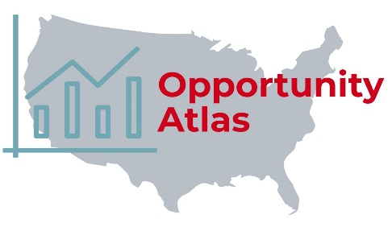
The Opportunity Atlas - The U.S. Census Bureau Maps the Roots of Social Mobility
In recent times, we hear a lot about how much America is changing - how different we are becoming. Regardless of topic, “the where”, “the what”, and “the who” are the questions that every community indicator must answer. But is that just hyperbole or can differences be quantified? Let’s see what the Opportunity Atlas - Roots of Social Mobility data visualization tells us.
When Wenatchee is chosen for the Location, the Outcome section populates showing that approximately 72% of people who grew up in Wenatchee stay in Wenatchee as adults. The Neighborhood Characteristics section populates showing us the poverty rate (2006-2010) was 12%, 27% of the population was non-white (2010) and about 30% of families with children were led by a single-parent (2006-2010). However, these are simply the default results for Wenatchee. Changing the featured topic will also change the map showing how other jurisdictions and topics compare to the selected location and outcome.
Although some of the data on the Opportunity Atlas isn’t as up-to-date as indicators on the Chelan-Douglas Trends website, it does incorporate maps, data, and graphs that are directly comparable to other locations across the U.S.
Additionally, having data that is a little older allows for location totals that include: the nation, each state, every county in the U.S., by metropolitan statistical area (MSA), by city, and even down to the census tract level.
The Where: search for a city or a region. The website offers many different population levels, such as state totals, county totals, metropolitan statistical area (MSA) totals, cities, and even down to the census tract level.
The Who and the What: Select outcomes, including but not limited to income rate, incarceration rate, employment rate, spouses income, and marriage rate. Additionally, options such as share staying in same location as adults, poverty rate, demographics of the location, including neighborhood characteristics are available.
<><><><>

Chelan-Douglas Trends Website New Look
The Chelan-Douglas Trends website has been completely redesigned into a new, even more user friendly format.
While the web design is new, many of the functions you have become familiar with have not changed. For example, the ability to switch views from the combined counties, to Chelan or Douglas County individually, or to either Wenatchee or East Wenatchee will work as they did before. Also, the More Information and Download Data sections work exactly as the previous version.
Search is one of the newest functions available on the Chelan-Douglas Trends website. Sitting directly above the new Hamburger Menu in the upper-right corner of the website, the Search function allows a user to type in a key word or phrase to quickly refine a search for relevant indicators.
Inside the hamburger Menu, you will also find both familiar and new features. They include:
- Indicators At A Glance - a complete list of each indicator in the website with a convenient direct hyperlink to each indicator in the title.
- Resources - a list of helpful community resources separated by category.
- In The Press - indicators that make the news are featured here.
- Other Sites - a list of community indicators websites facilitated by Eastern Washington University.
- Newsletter - subscribe, manage your account, and view archived newsletters.
- Blog - a list of the most recently updated indicators on the Chelan-Douglas Trends website.
- Compare - choose any two indicators from any community indicators website for a side-by-side comparison.
Community Indicator websites available in the Compare feature include: Benton-Franklin Trends, Grant County Trends, Kootenai County, Idaho Trends, NE Washington Trends [Ferry, Pend Oreille, and Stevens Counties], Skagit County Trends, Spokane County Trends, Walla Walla County Trends, and Yakima Valley Trends.
How can I stay involved?
- Follow us on social media - find links at the bottom of the open hamburger Menu.
- Subscribe to our Newsletter and Blog - send an email to srichter20@ewu.edu with “CDT Subscribe” in the subject line.
- Send us your photos! Do you have a high quality digital photo you would like to see on the website? Send it to srichter20@ewu.edu with “CDT Photo” in the subject line. We will be more than happy to add a photo credit with your name on it.
<><><><>

Indicators in Action:

Median Home Resale Value Increasing Steadily by Scott Richter and Dr. Patrick Jones
The boom in the housing market over the past few years has received a lot of attention. Increasing population in Washington State, fewer available lots suitable for building new homes, and a low number of homes available for sale have added to the increasing resale value of homes, not just locally, but across the state and U.S. too.
With the area receiving national accolades, such as making the Forbes list of Best Places To Retire in 2018, Chelan and Douglas Counties can no longer hide as one of Washington State’s best places to live, work, and play. Additionally, the growth of the economy on the West side of the Cascade Mountains has extended into the local area creating new jobs, while increased tourism has exposed more people to the advantages of living here. The result is more people from outside the local area, often with greater financial resources than the local residents, bidding on and purchasing homes potentially driving up home prices.
Supply side factors affecting median home resale values include new tariffs on lumber and a combination of skilled labor shortages and young workers not interested in construction work, rising rents, and a decreased number of foreclosures available.
According to the U.S. Department of Housing and Urban Development, Office of Policy Development and Research (HUD), homeownership is a “principal source of wealth accumulation for a majority of Americans [and] also provides a greater degree of insulation from rising housing costs allowing more income to be saved or put to other uses.” Homeownership "locks-in" monthly payments (assuming fixed interest loan terms) that become more affordable, provided household income increases, over time.
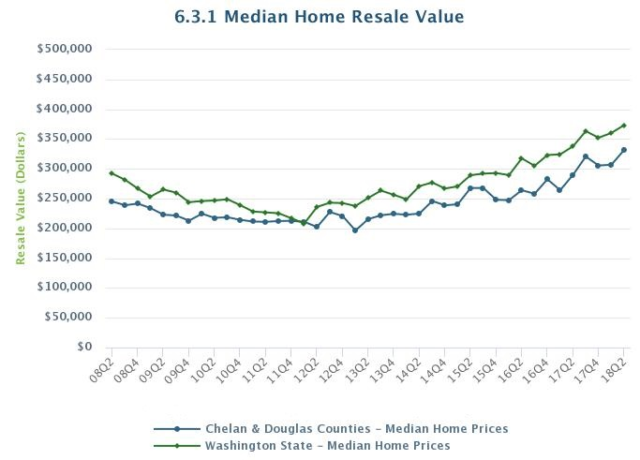
Affordable housing is important because low income households that pay a high percentage of income on shelter, regardless of renters or homebuyers, are at greater risk of becoming homeless. But strains on the housing market, such as a decrease in the typical number of homes on the market and home values increasing at a much faster pace than wages can have an effect on that accessibility.
HUD also points to new research quantifying non-financial benefits to homeownership, such as ‘improved housing quality, satisfaction, and conditions for childhood development.” Yet, the agency remains concerned about “the extent to which low-income or minority homebuyers share in the traditional benefits of homeownership”.
How do these considerations play out in the greater Wenatchee area? Chelan Douglas Trends covers 15 metrics of housing. Let’s consider a key one.
Looking at the Median Home Resale Value indicator, we see the trend line for the combined counties closely follows that of the state; however, it lies consistently below the state. While true
More specifically, during the second quarter of 2018 (18Q2), the median resale value of homes in:
- The combined counties was $331,678 increasing from $245,148, or by 35% since 2008Q2.
- Chelan County was $334,100, increasing from $251,500, or by 32% since 2008Q2.
- Douglas County was $327,900, increasing from $230,000, or by 46% since 2008Q2.
- Washington State was $373,400, increasing from $291,900, or by 28% since 2008Q2.
While the state has a higher median resale value than the combined counties and for Chelan and Douglas Counties individually, the growth rate since the start of the series for both counties has exceeded the state benchmark.
While not a new phenomenon, it’s also important to note at $334,100 during the second quarter of 2018, Chelan County has the highest median home resale value for counties east of the Cascade Mountains. Both supply and demand strains are contributing to the high median home resale value in Chelan County, as well as the popularity of vacation homes. To what degree each of these and other factors are contributing to the high median home resale value in Chelan County is uncertain, but each is a contributing factor.
In 2008, housing affordability in the two counties was the lowest among all eastern Washington metro areas, essentially the same as that of the state average. Since 2008, the median home resale value in the combined counties has increased by 35%; per capita personal income increased by 36%; median household income increased by 26%; and the nominal overall average annual wage increased by 25%. So, wage growth has been a little more sluggish than the growing median home resale value. Checking back on this indicator over the next few years will show us if the wage and housing gap have closed, or widened even further.
Securing affordable housing is an important aspect of Our Valley Our Future’s work “tackling tough community challenges and working toward transforming the region into a better place to live, work and play.” A variety of housing reports and surveys can be accessed from OVOF’s Library webpage.

<><><><>

Growth in Jobs Paying 25% More than Last Year’s Average Annual Wage by Scott Richter and Dr. Patrick Jones
Statistics on new hires and job creation can offer insight into the health of any local or regional economy. Job creation is a major goal of economic policy at any level of government and obviously not all jobs are of the same quality. So while it is important to know the number of net jobs created, it is perhaps more important to know the quality of jobs being created based on the income they provide.
Information on new hires is used by both public and private sectors to negotiate labor contracts, forecast tax revenue, evaluate a region’s economic health, and can even guide decisions on sales and inventories. But data on new hires alone, unfortunately, are not available at the county level. So the indicator looks at a net number, which includes job losses.
An approximation of job quality is to consider those new jobs that pay better than some benchmark. In this indicator, the benchmark is the average annual wage. And a premium of 25% to the average is considered “better.”
Since this is a novel measure of the labor market, let’s make a quick sketch of its construction. First, the overall average annual wage (AAW) from the previous year is multiplied by 125%. Next, the number of occupations paying more than 125% of the overall AAW from the previous year are determined. The net difference in the number of these jobs from the previous year to the current year is what is displayed in the graph. In sum, the net change from the previous year to the current year is what this indicator measures.
Looking at the Net Jobs Created at 25% Higher Earnings than Last Years’ Average Annual Wage on the Trends site, we see r the combined counties during the most recent half of the series fared better than the first half. The most recent half of the series produced a net increase of higher paying 2,162 jobs (from 2014-2015 to 2017-2018) while the first half of the series (2010-2011 through 2013-2014) produced a net decrease of 1,392 jobs.
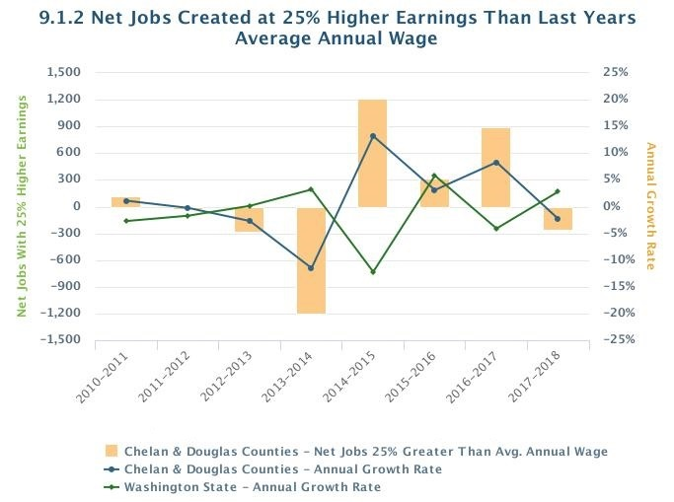
Although titled “net jobs created”, this indicator can simply be looked at as the growth or loss in the net number of jobs paying 25% more than the overall AAW of the previous year. It does not necessarily mean a job was eliminated if there was a decrease in this series from one year to the next. In theory, a job could be captured one year and not the next - even if the job doesn’t experience any significant changes in wages.
For example, a job might be included one year and just barely exceeded the 25% margin. The following year, the overall AAW might have increased enough to push it below the 25% threshold. In this scenario, there was a net decrease captured in this series but without the actual loss of a job.
Another example could be that a particular industry didn’t create or have any net growth in the number of jobs, but the wages in the industry grew at a rate that increased the net number of jobs paying above the 25% threshold.
While this indicator is based on occupation data, we do know growth of high paying jobs in Chelan and Douglas Counties have occurred within the following broad industry sectors: Healthcare (particularly in ambulatory health care services and at hospitals), Construction (heavy and civil engineering construction and specialty trade contractors), and Government (primarily at the local level, but due to an increase in the number of jobs and not drastic increases in pay).
Other industries paid 25% more than the overall AAW of the previous year, but lost employment. For example, Wholesale Trade (which includes merchant wholesalers of both durable and nondurable goods as well as electronic markets, agents, and brokers) experienced a net loss of 320 jobs from 2016 to 2017. The Finance and Insurance industry is similar. Wages in this industry have grown and consistently paid more than the 25% threshold but there has been a net growth of zero jobs from 2014 to 2017. So although this is a high paying sector, it has had little or no effect on this indicator because the net difference in the number of jobs paying 25% has not changed.
What does this mean for the two counties? Job creation and the “trading up” of existing jobs into higher pay ranges is not easy for most regional economies. Yet, a look at the graph and more accurately, the data behind it, reveals that compared to Washington State, the metro area is holding its own.

<><><><>

Rent Consumes a Large Portion of an Entry Level Wage Earners’ Budget by Brian Kennedy and Dr. Patrick Jones
We’ve all heard the story over the last couple years: rents are increasing and wages aren’t keeping pace. Those reports are often national or have a statewide focus. What is the story locally? And equally important, how is that balance of costs and income impacting newly educated individuals, fresh out of trade schools and universities? For those about to break into a healthy job market, are they facing tougher economic conditions while rent is consuming a larger portion of their household budget than for those who graduated ten years ago? Examining wages of entry-level jobs in relation to the median rent gives us insight to these questions and is exactly the intent of indicator 6.2.6.
Indicator 6.2.6 measures the annual median rent paid by renting households as a share of the average annual wage of entry-level jobs. Determining median rent is fairly straight forward. It’s the midpoint value where exactly half of all renting households pay more and exactly half pay less. In this context, according to the U.S. Census surveys, rent refers not only to the market rent but also other shelter costs such as water, sewer, garbage, and electricity. For simplicity, the costs will be referred to as rents here. In the Wenatchee metro area (comprised of Chelan and Douglas Counties) the median rent in 2017 was estimated to be $852 a month, or 70% of that in Washington as whole, which sat at $1,216.
Wages for entry-level jobs is less straightforward because there are no direct data on wages pertaining to what might be classified an “entry-level job”. In cases such as this, economists often turn to approximations. Here the average annual wages of individuals ages 22-24 are used as the proxy for entry-level job earnings. The data for the metro area are found in the Quarterly Workforce Indicator Explorer from the U.S. Census. This age group was used because it is the typical age individuals will be entering the job market, degree in hand from a university or tech school but often with little career experience. Locally, the average annual wage for an entry-level job in 2017 was $26,052, lagging behind the state average of $34,428, or by about $8,000.
Combining these two measures, we see that rent consumed about 39.1% of the average annual wage of entry-level jobs in 2017 in the two counties. Growing by a compound annual growth rate of 0.6%, this ratio is up 2.7 percentage points since 2005 when it stood at 36.4%. The Wenatchee metro area started off the series just 1.7 percentage points under the State, but by 2017 that difference had nearly doubled to 3.1 percentage points.
While over the entirety of the trend, the region has shown an increase in rents as a share of entry-level wages, in the last six years that share has started to fall. Shortly following the Great Recession (2011), the share peaked at 46.1%. This was one of only two years where the local ratio was higher than that of the state, which also peaked in the same year at 45.2%. Since then there has been a gradual decline both locally, by a compound annual rate of 2.3%, and statewide, by a rate of 0.9%.
This decline of rent to entry-level wages can largely be attributed to the growth in wages. In 2011 the average annual wage for an entry-level job was about $19,500 in the Wenatchee metro area. This grew by a compound annual growth rate of 4.3% to 2017 where it sat at about $26,000. Over this same period median rent grew by just 1.8%, compounded annually, increasing from roughly $750 a month to just over $850. Wages of this group in the metro area marched upward, largely on par with the state growth, at just 0.6 percentage points lower. The real difference lay with the growth rate of rents. Statewide, they more than doubled the local median, increasing by 3.9% since 2011.Simply put, local wages and rent prices have weathered the recovery relatively better than statewide estimates.
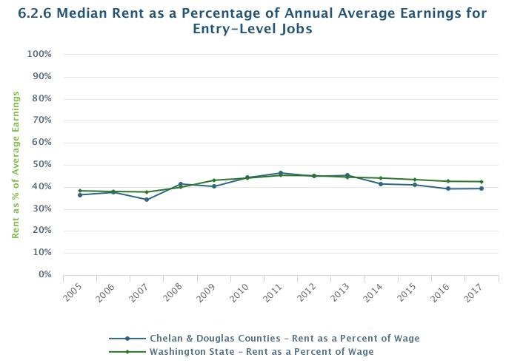
Other support for this assessment comes from indicators 6.2.4 and 6.2.5. The indicators represented here show the share of households that spend 30% and 50%, respectively, of their income on rental costs, defined as gross rent the same as above. By definition, these measures look at all renting households, setting aside their job level. Here too, Chelan and Douglas Counties are faring better than both the state and national trends.
In 2017, about 30% of renting households dedicated 30% or more of their income while 12.5% were paying 50% or more of their household budget to rental costs. In a state whose averages are largely driven by the high wage markets on the west side, rents still take a substantially larger portion of the household budget than observed locally. Statewide, 45% of renters are paying 30% or more of their income on rents, 15 percentage points higher than the Wenatchee metro area. Statewide, 21.2% of renting households fell into the category of paying 50% or more, or nearly 9 percentage points higher than the locally community. National trends have followed suit of that of Washington. While it might surprise, Chelan and Douglas County residents are spending less of their budget on rents, leaving them with more money in their pockets for other discretionary spending.
Up to now the focus has been on the rental market. What does that ratio look like for those wishing to be home owners? Indicator 6.3.1 pulls data from the University of Washington Runstad Center for Real Estate, and tracks the median home resale value. Taking an annual average of the 2017 data shows that the median home resale value is about $295,010 locally and $344,350 statewide. This is roughly 11.3 times the average annual wage for an entry-level job in the Wenatchee metro area and 10 times statewide estimates. However, this ratio has been growing since 2005, where it was at 9.3 times the entry-level wage. This trend diverges from the state which has shown a decrease since 2005, where it was 11.1 times the entry-level wage.
So while rents (or better, shelter costs) as a share of the entry-level wage seem to be on the decline after a brief run up to the Great Recession, the same scenario can’t be said for homebuyers in Chelan and Douglas Counties. In the most recent years, wages for those new to the labor market are starting to increase at a rate fast than rents but home price appreciation is still outpacing them both. It’s not surprising, then, if individuals are renting a bit longer, waiting for that next job promotion, in order to save up enough to purchase a home.
<><><><>

5-Questions with: Heidi Myers, VP of Corporate Banking, Washington Trust Bank
Q1: As much as any business, banks depend on data. Can you highlight for the readers any particular measures that define your sense of success at Washington Trust Bank in the greater Wenatchee area?
A1: Success as a commercial banker means taking excellent care of the financial needs of our customers. This includes obtaining a thorough understanding of how their business operates, offering efficient responses to banking needs, and partnering for success in a competitive environment. Some measures that reflect success are total dollars loaned, timely collection of the loaned money, and interest earned for the bank and longtime loyal customers.
Q2: You’ve been professionally involved in banking for nearly two decades. To what degree have you seen a greater data flow in the sector and a parallel demand to use it effectively?
A2: One of the ways bankers analyze business financial statements is by comparing performance to industry standards. We have access to an extensive data base of ratios and performance measures for almost any industry. However, it is important to keep in mind that one business here in Chelan County is being compared to similar sized business across the country, and that industry norms can differ vastly by region. For that reason, access to local and regional data helps me put a local perspective on the analysis of a customers’ business results
Q3: Can you tell us how Chelan Douglas Trends helps the work of you and your colleagues at Washington Trust?
A3: It is very helpful to have the website available to guide our thoughts on economic vitality, housing, transportation and people (population data). For instance in lending to a business that is targeted at a older demographic, we can see that the median ago of our two county population is higher that state and national average and has increased from 37 to 39 years in the past 12 years, while the 0-17 age group has declined steadily.
Q4: Beyond Trends indicators that may assist your work at the bank, are there other measures in Chelan Douglas Trends that grab your attention?
A4: Yes, the Our Valley Our Future data is so interesting. The jobs created at 25% higher earnings that last year’s average wage – it sounds so complicated, but what a fascinating indicator of economic development. We can see an absolute plunge in 2014 – I would guess as a result of Alcoa’s shut down, followed by a huge rebound in 2015 (re-hires?) and then some ups and downs in subsequent years. I serve on the NCW WorkForce Development Council, whose mission is to work with local schools and other partners to provide training and education to youth and adults in transition into good jobs. Workforce Development needs data like this to guide our thinking on how to accomplish our goals in our area.
Q5: You’ve been involved in several organizations in the community. Over that time, what, if any, increase in data-based decision-making have you observed? Is the area becoming more “numerate”?
A5: I love this question – at a recent board meeting for a ministry I am involved in (Young Life) we were discussing our efforts to support teenage mothers in the area. We had noticed a decline in attendance at events for this demographic, and I was able to pull up the Trends website and note the decline in births to 15 – 19 year olds in Chelan and Douglas County over the past ten years. (From 203 per 1000 in 2006 to 91 per 1000 in 2016.).
I believe that as our region grows, decision maker are using more data about our area for planning and strategy.
<><><><>

