Chelan-Douglas Trends Newsletter: #3 2018

Welcome!
Welcome to the latest and greatest edition of the Chelan Douglas Trends Newsletter! The Trends website is an online resource that provides a wide variety of data and information about Chelan & Douglas Counties. While the data is gathered, updated and housed by the Institute for Public Policy and Economic Analysis and the Center for Digital Media Design and Development at Eastern Washington University, it is the community that determined, through a collaborative process in 2008 and on-going, what data is most important and helpful to be included on the website. The overall purpose of the project is to help improve our local communities’ decision-making processes by providing access to important, and neutral, information that helps show our communities in the context of the same data for Washington State and the Nation. As the economic development entity for Douglas County, the Port is a significant user of the Trends website. It is a major source of data that we use to help us better understand the economic climate and conditions for our community, making our efforts to enhance and bolster our local economy more practical and productive. I encourage you to explore and take advantage of the website, and hope you enjoy this issue of the newsletter!
Lisa Parks, Executive Director, Port of Douglas County
<><><><>

Indicators in the News:
Welcome to the Chelan-Douglas Trends Blog!
Most indicators on the Chelan-Douglas Trends website are updated annually, although some indicators can only be updated every two-years and others every five-years. There are even a few indicators receiving updates as frequently as four times a year.
However, even the most enthusiastic user of the Trends website has had no way to tell for sure when an indicator was updated - until now.
Subscribers to this newsletter received an email a few weeks back introducing them to the new Chelan-Douglas Trends Blog. As the email explained, the blog will be used to keep everyone up-to-date as to what indicators were recently updated. Future emails will offer a quick summary with a hyperlink that will take you directly to the blog. The blog will simply be a list newly updated indicators. Indicator titles will be clickable hyperlinks taking you to the specific indicator on the Trends website.
Subscribers to the newsletter will receive blog updates, so no need to subscribe to both.
In the future, emails about blog updates will be sent from this email address: indicatorsmanager@ewu.edu. Make sure to add it to your list of Safe Senders so you don’t miss a single update.
If you missed the email, you can check out the blog by clicking here.
As facilitators of the Chelan-Douglas Trends website, we hope you enjoy seeing new data and how it compares to previous years or to other closely related indicators as much as we do. We believe keeping you up-to-date through the blog will help you get even more out of the Chelan-Douglas Trends website.
Thank you!
<><><><>

Country of Origin for Migrants Living in the U.S.
Quality data can serve as a starting point allowing people to talk about sensitive subjects. Good data can also help us cut through the noise created by highly charged, political hot-button topics, such as immigration and immigration policies in the U.S.
Pew Research tracks the country of origin for international migrants living in the U.S. going back to 1990. Pew’s numbers represent all people born outside of the U.S. who are currently living in the U.S. and includes: naturalized citizens, people on a work visa or through another legal process, and undocumented immigrants.
An international migrant is defined by the United Nations Population Division as “someone who has been living for one year or longer in a country other than the one in which he or she was born.”
So, where are we? According to Pew, the estimated total number of international migrant living in the U.S. during 2017 was 49,780,000, or about 15.3% of the total U.S. population.
More specifically, the top-10 countries of origin for international migrants living in the U.S. during 2017:
Immigrants In The U.S. - 2017
Country of Origin | Total Immigrants | Share of U.S. Immigrants | Share of Total U.S. Population
Mexico | 12,680,000 | 25.47% | 3.89%
China | 2,420,000 | 4.86% | 0.74%
India | 2,310,000 | 4.64% | 0.71%
Philippines | 2,080,000 | 4.18% | 0.64%
Puerto Rico | 1,900,000 | 3.82% | 0.58%
Vietnam | 1,410,000 | 2.83% | 0.43%
El Salvador | 1,390,000 | 2.79% | 0.43%
Cuba | 1,250,000 | 2.51% | 0.38%
South Korea | 1,180,000 | 2.37% | 0.36%
Dominican Republic | 1,070,000 | 2.15% | 0.33%
Canada | 890,000 | 1.79% | 0.27%

While Canada is not the 11th highest country of origin for international migrants living in the U.S. during 2017 (Canada is in 12th place), it was included due to its close proximity.
<><><><>

Choose Chelan County Property Site Selector
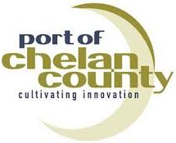
Property site selector websites have been popping up across the U.S. recently, but the Choose Chelan County property site selector is unique by not simply allowing searches for available land and buildings, but searches for all commercial properties in the county either by entering specific information (size, location, zoning, etc.), or through an interactive map.
The Available Properties option has filters for office, industrial, or retail, and whether the property is for sale or lease. Information provided include the lease or purchase price, building details (size, number of floors, year built), lot size, available parking, type of space (industrial, commercial), and contact information for the owner or property manager.
The All Commercial Properties option provides information on the owner or property manager, zoning, current use, size in acres, and the assessed value.
Additionally, you can look up an existing business by name, location, number of employees, annual revenue, or by 6-digit NAICS number. These search functions can be filtered to cities, or for the county as a whole.
So whether you are a business representative looking for commercial property to buy or lease for a business relocation or expansion, an individual looking for companies to do business with, or just curious as to what businesses exist in Chelan County, the Choose Chelan County property site selector can help you out.
<><><><>

Indicators In Action:

Local Public Expenditures on Road Maintenance Above State Counterparts by Scott Richter & Dr. Patrick Jones
A safe and effective road system is crucial for the transportation of people, as well as the goods and services people rely on. Most regional roads are financed and maintained with local public funding. Public funding levels can be a reflection of the quality and safety of local road systems. Economic growth and vitality depends on the ability of people and goods to move freely from one area to another.
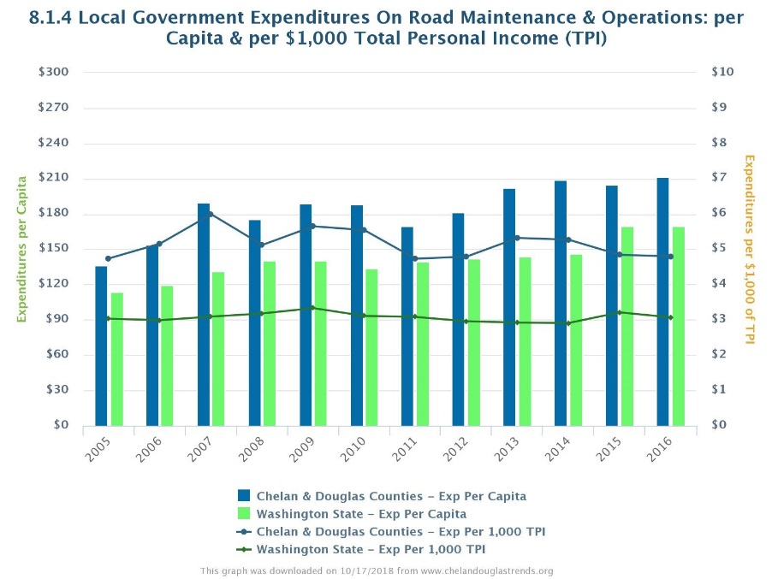
Since mobility is important to a community for many different reasons, local government expenditures on road operations and maintenance is tracked on the Trends website two ways: first is on a per capita basis (expenditures per person) and per $1,000 of total personal income (TPI).
The U.S. Regional Economic Analysis Project defines Personal Income as “income that is received by all persons from all sources. It is calculated as the sum of wage and salary disbursements, supplements to wages and salaries, proprietors' income with inventory valuation and capital consumption adjustments, rental income of persons with capital consumption adjustment, personal dividend income, personal interest income, and personal current transfer receipts, less contributions for government social insurance.”
Total personal income (TPI) is the total sum of all personal income earned by all persons in an area – before any taxes are paid. Using the local government expenditures per $1,000 TPI ratio allows us to understand how big a share of a resident's budget is contributed to road maintenance and operations.
Examining the Local Government Expenditures on Road Maintenance & Operations indicator, we see both the per capita and per $1,000 TPI in the combined counties have consistently been above the state benchmarks.
More specifically, during 2016, per capita expenditures were $211.70 in the combined counties, compared to $169.90 as an average of local government expenditures across the state. Expenditures per $1,000 TPI was $4.80 in the combined counties compared to $3.10 as an average of local government expenditures across the state
During 2016 Chelan County individually, local government expenditures were $188.40 per capita and $4.00 per $1,000 TPI. Also during 2016, Douglas County local government expenditures were $255.30 and $6.80 respectively.
While TPI is not available at the city-level, during 2016, the City of Wenatchee local government expenditures on road operations and maintenance were $72.30 per capita and the City of East Wenatchee were $100.20.
Rob Jammerman, Public Works Director for the City of Wenatchee, says road maintenance and operations funds are used for road crew salaries and benefits, traffic control (lights and signs), sidewalks, lighting, cleaning and sweeping, and snow and ice removal.
Jammerman said “Our existing infrastructure needs to be cared for because it has a limited lifespan. Without constant maintenance, the roadway eventually becomes unrepairable leaving a complete replacement as the only option, which is much more expensive than routine maintenance.”
The City of Wenatchee Annual Street Preservation fund, which does not come out of the road maintenance and operations budget, proactively funds repairs to roadways so they do not fall to a level requiring a complete replacement. Roadway degradation can be caused by general wear and tear, studded tire damage, utility street cuts, and cracks naturally forming in the asphalt. If left unrepaired, these issues can lead to larger issues such as potholes, depressions or distortions on the surface, an increase in the number and size of surface cracks, and the start of surface disintegration.
Because complete reconstruction of roadways are more expensive than maintenance, Jammerman says, “Jurisdictions can reduce large investments if they focus on programmatic maintenance.”
For large street improvement projects, Jammerman said state and federal funds are usually applied for via grants often require local government to fund a certain percentage of a project. If a federal or state grant is awarded requiring local funds as part of a grant match, those funds come out of local road budgets, but are specifically earmarked for grant match opportunities.
As with most government budgets, fund allocation is a delicate balance of what makes us healthy, happy, and safe. While police and fire take up large parts of a local government budget, it’s also important to make sure the flow of people and goods are not slowed or stopped due to potholes in the summer and snow berms in the winter.

<><><><>

Kindergarten Readiness Below State but Improvements Observed by Brian Kennedy & Dr. Patrick Jones
For the uninitiated, the acronym WaKIDS is hard to decipher. Something to do with children, and maybe something to do with Washington state. Spelled out, it stands for Washington Kindergarten Inventory of Developing Skills, an assessment all public kindergarten students take in the first couple months of the school year. And it has become critical in understanding the state’s early learning efforts
The Office of Superintendent of Public Instruction (OSPI) doesn’t refer to WaKIDS as a test but rather an assessment carried out by the teachers. The assessment became mandatory for every child in state-funded full-day kindergarten classrooms in 2012-2013. Other schools, such as private elementary schools, may choose to participate. It exists because of a partnership between the Department of Early Learning (DEL) and the OSPI, with private support from the Bill and Melinda Gates Foundation and Thrive by Five Washington.
During the assessment, kindergarten teachers observe their students during everyday classroom activities and take inventory on each child’s success in six skillsets; social-emotional, physical, cognitive, language, literacy, and mathematics. This assessment is designed to show whether or not students are demonstrating characteristics of entering kindergarteners. It is not used in order to determine if the child should be entering kindergarten. In the Eastmont school district, according to Penny Brown, Assessment Coordinator and Principal at Rock Island Elementary, these results are then shared with parents at the October conferences and provide ideas for parents about how they can help at home.
Data from indicator 3.1.12 show that across all school districts within Chelan and Douglas Counties the share of entering kindergarteners showing kindergarten level skills in all six domains is just shy of 40%, or 2 out of every 5 students. This is, however, a marked improvement from the inception of the assessment, up about ten percentage points from 2012-2013 (30.8%). Yet, regional kindergarten readiness is still falling short of the state benchmark by about 7 percentage point, which sits at 46.7% for the most recent school year.
The difference is largely due to the combined counties showing a higher percentage of entering kindergarteners show adequate skills in just one domain or none at all than the state average. Locally, the region has 16.4% of students in this category while statewide the number is just 11.6%. This set of students, too, has improved since the onset of the assessment but has made its biggest improvements since school year 2014-2015, where 20% of the students, or one in five, were only ready in no or just a single domain.
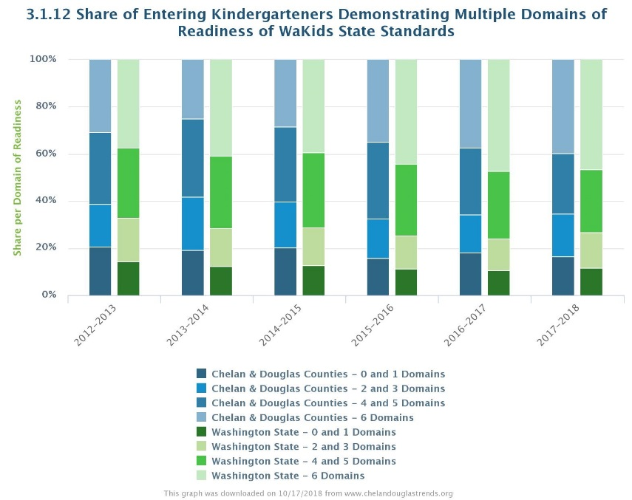
Considering the counties separately, we see some large differences within the region. The Wenatchee school district, which accounts for 57% of the students tested in Chelan County, had just 32% kindergarteners ready in all six domains and 17.8% of students ready in one or none of domains in the most recent reported assessment. Eastmont, on the other hand, is outperforming the combined counties’ average, reporting most recently that 43.4% of students ready in all six domains while 15% students ready in just one or none of the domains.
Brown mentions that demographics and language may have something to do with the initially low numbers. “Language is obviously a challenge especially if we don’t have the teachers that speak Spanish to help these little ones create a bridge between their home language and English Spokane at schools.” The population of the combined counties reveal a statistically significant difference to the state of the share of Hispanics or Latinos residing in the region. According to Census data, found in indicator 0.2.2, nearly 30% of the population is Hispanic, over double the state rate of 12.7%.
While the local community appears behind at the onset of a child’s education, by 4th grade, when students take the Smarter Balance Assessment (SBA), improvements have been made. Indicator 3.1.4 shows the share of students meeting the standards in the language arts portion the SBA. In the combined counties, 50.1% of the students met those standards most recently. While this is still below the state rate of 56.2% the improvement is apparent. Although the two assessments aren’t directly comparable, they do provide f insight to the improvements students have made.
Most recently, the Wenatchee school district reported 46.3% of their students meeting the 4th grade standard versus 32% of the entering kindergarteners showing readiness in all six domains. The Eastmont district reported 59.4% of their students meeting the SBA standards, roughly three percentage points higher than the State rate. Brown attributes this improvement in part to English Language Specialists in the district and language development programs such as Imagine Learning. She goes on to state that “the quality of the classroom teacher is the greatest determining factor in a child’s growth, so I guess we can assume we have a gifted group of teachers in our district.”
The Department of Early Learning states, “School readiness is not just whether the child is ready to succeed in school. It is also whether schools and communities are ready to support that success”. As the data demonstrate, the average current WaKIDS score of the two counties points to underperformance to other districts across the state. Yet, despite unique demographic and language challenges directly impacting student performance on standardized assessments, the region’s school children bounce back, due to an excelling teaching staff and programs. It appears that t the community is ready to support and build upon the success of their children.
<><><><>

Taxable Retail Sales Setting Records by Scott Richter & Dr. Patrick Jones
Annual taxable retail sales represent one of the most important measures of the size and changes in a local economy. These sales often serve as a key proxy of total county economic activity, since consumption forms the largest part of any economy.
Taxable retail sales provide critical financial support to local and state government entities, as they provides the largest share of revenues to both levels of government. The level and growth of taxable retail sales provide a sense of how well the economy is doing.
Taxable retail sales include, but are not limited to: retail trade (furniture, home and garden centers, vehicles, department stores, restaurants, etc.); agriculture, forestry and fishing; mining; manufacturing; finance and insurance; arts and entertainment; and real estate. All sales subject to the retail sales tax, including online sales, are captured in this indicator.
Taxable retail sales represented in this indicator apply to retail trade and construction activities in both the private and public sectors. But since Washington State does not tax all consumer categories, including food, drugs, and some services, as insightful as the taxable retail sales figures are, they do fall just a little short of providing a complete picture of all consumer transactions.
Not included taxable retail sales is incomplete, since Washington State does not tax categories such as food, drug, and importantly, most services.
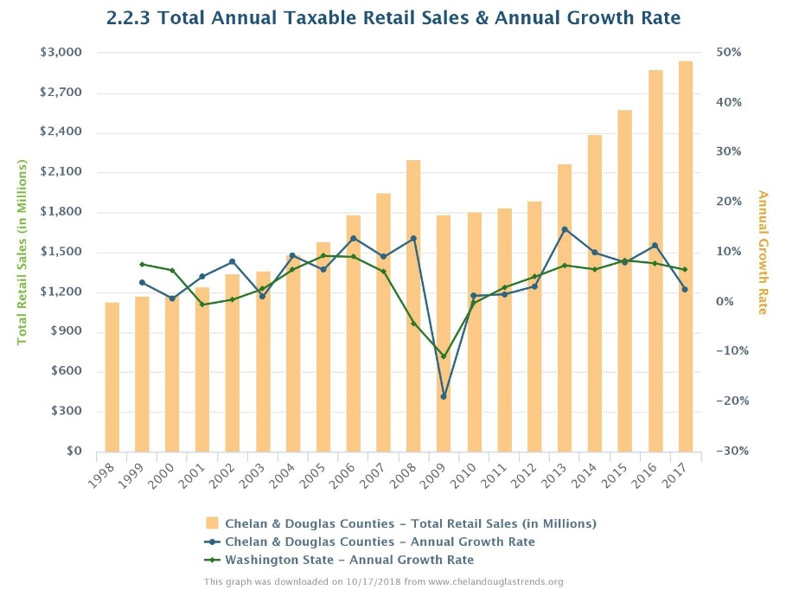
Looking at the Total Annual Taxable Retail Sales & Annual Growth Rate for Chelan and Douglas Counties combined, two positive signs really stand out for 2017: the $2.95 billion in taxable retail sales are the highest in the series and are the eighth consecutive year producing an annual increase.
Individually, Chelan and Douglas Counties produced $2.03 billion and $923 million, respectively, in taxable retail sales during 2017. Each of these are the highest in the series. Chelan County has had six consecutive annual increases, and Douglas County eight.
During 2017 the taxable retail sales for the Cities of Wenatchee and East Wenatchee were the highest in the series, producing $1.1 billion and $437 million, respectively. Roughly 54% of all retail sales in Chelan County took place in Wenatchee and 47% of all retail sales in Douglas County occurred in East Wenatchee.
Linda Haglund, Executive Director, Wenatchee Downtown Association said, “Wenatchee is a hub of shopping and care facilities in this region. As the region grows, so should our economic vitality.”
What might be driving these increases? It's not real estate, as taxes paid on these transactions are not included in the taxable retail sales figures. However, taxable retail sales of home improvement products and big ticket items purchased at furniture stores, for example, are significant.
“We hear a lot that downtowns and small business is suffering due to the Amazon Effect. What I have seen, and this shows it correctly, is that in THIS community we value small business and we DO shop local”, said Haglund.

<><><><>

5-Questions with: Jim Richardson, CEO of Wenatchee Valley College
Q1: The Wenatchee Valley College has recently adopted a new, 5-year strategic plan, based around five themes. Can you briefly describe the plan?
A1: The strategic plan focuses on the four core themes from WVC’s mission: Providing educational achievement, support for learning, being responsive to local educational needs, and providing for the diversity and cultural enrichment of the college and its district. The fifth theme of the plan is centered on improving the college’s stability, sustainability and transparency. Each core theme has a primary goal with specific objectives. Our faculty and staff serve on core theme councils where they plan, develop and accomplish specific projects to meet the objectives outlined in the strategic plan.
Q2: How will the College measure the plan’s success?
A2: We assess the success of our mission, core themes and strategic plan in several ways. Annually, the college produces a report on mission fulfillment and progress toward meeting set indicators of success. As we improve and accomplish the goals and objectives, those indicators should reflect the progress WVC makes toward meeting the strategic plan. In addition, the aforementioned core theme councils build projects and programs around the plan, monitor progress and complete goals. Other measures, both internal and external, will reflect the college’s progress. Some of the Chelan-Douglas Trends indicators for the college, its service district and the regional economy should eventually reflect the progress we are making to meet our mission, core themes and strategic plan.
Q3: You have been involved in the Chelan Douglas Trends project nearly from the beginning. Which indicators are the most important to the College?
A3: The indicators related to education are of prime importance to the college. Those include education items that are not necessarily specific to WVC. Indicators on where and how students are coming to WVC and where students go after leaving the college are very important. In addition, WVC needs to be fully aware of its community’s economic and cultural needs. The college needs to adapt to changes in the demographics, culture, economy and security of its community. The indicators in Chelan-Douglas Trends provide an important primary source for the college to document and track changes. The data helps inform the decisions we make to support the community.
Q4: Looking at the Trends more broadly and even personally, are there any indicators that have given you an “aha!” moment?
A4: The indicator related to educational attainment, and specifically those that have baccalaureate or graduate degrees, stand out. When coupled with the economic activity and labor force indicators, it becomes abundantly clear that there is a real need for baccalaureate and graduate degrees to meet the economic and social future of the community. This “aha” moment led WVC to develop and offer bachelor of applied science degrees (BAS). Last academic year, WVC launched its first two BAS degree programs, a Registered Nurse to Bachelor of Science in Nursing (RN to BSN) and a Bachelor of Applied Science in Engineering Technology. WVC is actively working to offer more BAS programs in the near future. All of these BAS programs will be aimed at meeting community needs based on data from sources like Chelan-Douglas Trends. Having access to these data helps the college make informed choices about educational offerings for its communities.
Q5: Data-driven decision-making has become a buzzword in many communities over the past decade. You’ve been here now over a decade. Have you noticed greater attention paid to this kind of information in the greater Wenatchee area?
A5: This is more than a buzzword. It marks a significant change of culture that is happening worldwide and in our community. Data continues to grow in its importance to decision making in our area. A great example of this is the Wenatchee Valley’s Our Valley, Our Future initiative. The data collected for the initiative has affected programs in our community. Its data influenced WVC’s own strategic plan. Tracking and measuring data is key to maintaining progress and achieving success on the more than 150 projects and programs the initiative works with. As WVC is an active partner with Our Valley, Our Future, Chelan–Douglas Trends and other initiatives in the community, data-driven decision-making will continue to inform its decisions and will lead to improving the quality of life in our valley.
<><><><>

