Chelan-Douglas Trends Spring 2017 eNewsletter

News from the Region!
In 2008 the Chelan Douglas Trends website was launched, and those of us involved anticipated the resource would become a vital tool for government and social service organizations. Today, all sectors find the vast amount of information, housed in one easy to use site, an important resource and time saver.
Here at United Way we find the Chelan Douglas Trends website invaluable to our work. With our focus on early childhood education, alleviation of poverty and youth engagement we can easily access data points to help us understand changes, identify focus areas and develop strategy. Numbers help to tell a story, numbers remove the descriptor of “we think” to “we know”. Numbers help us make decisions on where and how to allocate our resources to improve lives. But, of course it more than just numbers.
What is really great about the Trends website is the story behind the numbers. If you have not, I encourage you to visit the website, select any indicator and then select the “More Information” tab. This tab and the wealth of information it contains brings the numbers to life.
I hope you enjoy this edition of the newsletter, the stories it contains, and perhaps you will take a few minutes to visit the website, select an indicator and go one step further to discover what is behind the “More Information” tab.
Alan Walker - President of Chelan & Douglas United Way

Indicators in the News
CDC 2015 Community Health Status Indicators
The Community Health Status Indicators (CHSI), from the Centers for Disease Control and Prevention, is an online web application that produces health status profiles for each of the 3,143 counties in the United States and the District of Columbia. The CHSI has been around since 2000 when it was released in “hard copy format” and was produced in its first interactive website in 2008. The CHSI 2015 redesign provides a completely revamped interactive experience, offers an updated list of “peer counties” for purposes of benchmarking, and a summary comparison sheet. The summary comparison sheets are provided for all 3,143 counties in the U.S.
For example compared to peer counties across the U.S., Chelan County residents fared better in cancer deaths and chronic kidney disease deaths but fared worse in Alzheimer’s disease deaths. Douglas County residents fared better in both male and female life expectancy but fared worse in Alzheimer’s disease deaths.
-----
Data.WA.gov - “The general purpose open data portal for the State of Washington”.
This data hub provides access to data sites in Washington State such as: fiscal.WA.gov, geography.WA.gov, business.WA.gov, results.WA.gov, education research, a “new and notable” section, a “general data catalog” for the state, and education research.
-----
Child Well-Being Data Portal - Washington State County Reports
Washington County Reports offers information on child welfare from the Child Well-Being Data Portal for each county in Washington State with populations over 25,000 people. Produced quarterly, the portal reports on “two major parts of the child welfare system: “Investigations & Assessments” and “Out-of-Home Care”.
Specific to Chelan County, as of January 1, 2017, there were a total of 108 open investigations and assessments and as of April 1, 2017, there were a total of and 102 open out-of-home care cases with 42% of these involving children under 5-years of age.
In Douglas County, as of January 1, 2017, there were a total of 69 open investigations and assessments and as of April 1, 2017, there were a total of and 65 open out-of-home care cases with 40% of these involving children under 5-years of age.

Indicators in Action

Share of Population in Poverty Below Benchmarks by Scott Richter and Dr. Patrick Jones
A dichotomy of life in one of the most prosperous countries in the world is that a large segment of the population is living near, at, or below the Federal Poverty Line (FPL). According to Child Fund International, “despite the fact that America is one of the world's wealthiest nations, poverty levels across the United States are among the highest of any developed nation.”
Measuring poverty might be just as difficult as eliminating it. In fact, software is being developed using satellite imagery that can be used in conjunction with more traditional surveys, to offer more insight into poverty conditions across the globe.
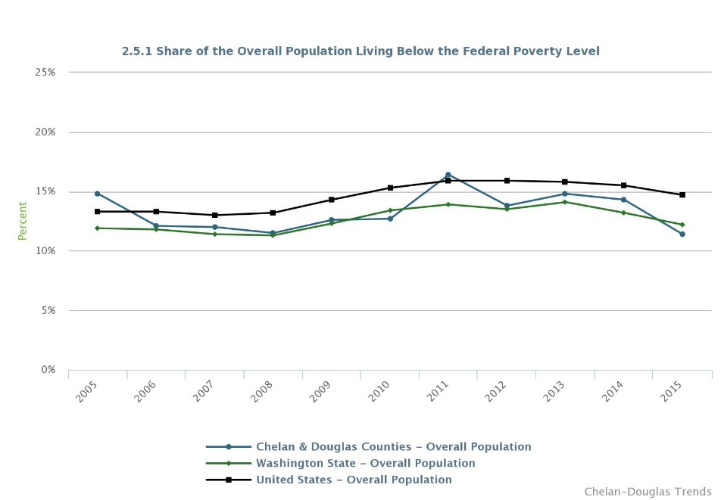
In the U.S., there are two main types of poverty measurements used by the federal government. According to the U.S. Department of Health and Human Services, Office of the Assistant Secretary for Planning and Evaluation, “Poverty thresholds are used for calculating all official poverty population statistics — for instance, figures on the number of Americans in poverty each year… [and] poverty guidelines are a simplified version of the federal poverty thresholds used for administrative purposes — for instance, determining financial eligibility for certain federal programs.” In short, poverty guidelines are produced by the Department of Health and Human Services, while the poverty thresholds are produced by the U.S. Census. This indicator is sourced by the U.S. Census American Community Survey (ACS), which is an estimate based on survey results, is helpful in making jurisdictional comparisons.
To calculate poverty thresholds, the U.S. Census determines both income and need for households. Income is the “incomes of all related family members that live together” and need is the “dollar amounts used to determine poverty status”. In short, poverty thresholds take into consideration the number of adults living in the household (1 or 2), total household income, and the number of dependents. If a family’s total income is less than the associated poverty threshold, the family is living in poverty. If a family’s income is equal to or greater than the associated poverty threshold, the family is not living in poverty.
An examination of the first graph, the Share of the Overall Population Living Below the Federal Poverty Level (FPL), reveals that 2015 represented the first year since 2010 where the share of the population living below the FPL in Chelan and Douglas Counties was below the state share. More precisely, an estimated 11.4% of the population was below the FPL compared to 12.2% in the state and 14.7% of the U.S. Since 2005, these rates have changed from 14.8%, 11.9%, and 13.3% respectively.
According to Alan Walker, President of Chelan & Douglas United Way, “Certainly the recession had a significant impact on people of all economic demographics, resulting in [more] middle and low income residents [entering] into poverty. Housing, job creation, higher education enrollment and business expansion all halted, or experienced slowdowns. As the economy started to recover we saw growth in the aforementioned areas, unemployment rates started to drop, housing starts resumed, and businesses started to hire and expand.”
The second indicator, the Share of Population Under Age 18 Living Below the FPL, shows during 2015, the share of the youth population in Chelan and Douglas Counties combined who were living below the FPL was 17.0%, compared to 15.5% in the state, and 20.7% in the U.S. Since 2005, these have changed from 21.0%, 15.1%, and 18.5% respectively.
Specific to the youth indicator, Walker believes “…this equation needs to address the total population of children living at home under the age of eighteen and the number of single parent households.” [Walker says], “if you have a single parent with three children, obviously the number of children in poverty is higher than the one adult. This helps explains some of the variance, but, we also have to recognize the cycle of generational poverty, and if the three children are growing up in poverty, what is the likelihood they will live in poverty as adults. Breaking the cycle of poverty should be the focus area.”
While both poverty indicators are trending in the right direction in the two counties, there is a lot of uncertainty regarding the potential funding cuts from the federal government regarding social services and the safety net they provide in times of need. Potential cuts could also affect funding for training, workforce development grants, and perhaps even higher education. Therefore, it is important to keep an eye on these indicators moving forward to see if they are continuing their welcome declines.
-----

Running Start Continues Strong Enrollment by Scott Richter and Dr. Patrick Jones
“Two Outs with One Pitch”, “Double-Up”, “Twofer”, and Dual Credit high school courses - who says high schoolers can’t have their cake and eat it too?
High school students who take full advantage of the Running Start (RS) program can complete their first two years of college at the same time they complete their last two years of high school.
RS students can take some or all of their classes at a college or university, and can participate in RS as high school juniors, seniors, or both years. RS students have access to the entire course catalog of the college they are attending; they simply must address pre-requisite requirements like any college student. RS students can take both traditional college courses and vocational courses. They are able to earn an Associate’s degree if they take classes at a community college, or complete their General Education Requirements preparing for a four-year degree at any of the five public universities in Washington State.
The graph for the Number of RS Students and their Share of the 11th and 12th Grade Enrollment in Chelan and Douglas Counties shows that during the 2015-2016 school year, total RS enrollment was 435 students, increasing from 165, or by 164% since the beginning of the series during the 1997-1998 school year. As a share of the 11th and 12th grade enrollment, RS enrollment was 14.5% during the 2015-2016 school year, exceeding the state share (14.4%) by 1/10 of a percentage point. The 2015-2016 RS enrollment in the combined counties was the third highest in the series and the overall trend from beginning to end is a steep incline.
Chelan County, Douglas County and the City of East Wenatchee all have similar trend lines - a generally steep increase from the beginning of the series, with a drop-off over the last couple of school years. During the 2015-2016 school year, the City of Wenatchee matched 2011-2012 as the year with the highest actual number of RS students, 179, and produced the second highest share of the 11th and 12th grade enrollment in the series at 14.5%.
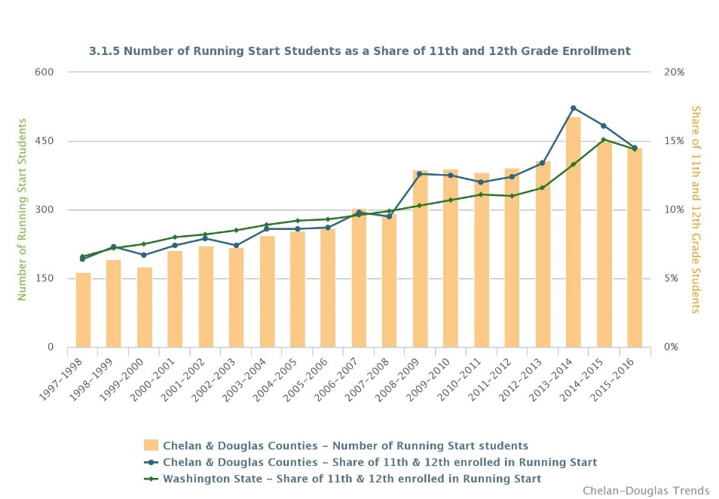
Perhaps part of the reason for the declining numbers of RS participants over the last two school years are the other options high school students in Washington State have to earn dual credits. Ultimately, RS is one of a many “dual-credit” options for high school students to simultaneously earn high school and college credit. As previously mentioned, this indicator has increased by 164% since the beginning of the series, but has only declined by 13.9% since the high mark since the 2013-2014 school year.
According to the June 2014 report “Learning by Choice: Student Enrollment Options in Washington”, along with RS, high school students have a quite a few options to earn dual credits. There are Advanced Placement (AP) courses, College in the High School, the International Baccalaureate, and the Tech Prep program. Although each program is unique, the similarity among each is that they provide the ability for the high school students to simultaneously earn high school and college credits. Part of the same “Learning by Choice” legislation of 1990, middle school students have the opportunity to earn high school credits if they successfully meet the academic requirements of an eligible course.
Will White, counselor at Wenatchee High School Counseling and Career Center, says “At Wenatchee High School we're seeing an increase in both Running Start students and students taking advantage of College in the Classroom. We're working to create as much flexibility and as many options for our students as we can. Along with potential credit tied to AP testing we offer a nice menu of opportunities for our students.”
Although this indicator has seen slight decreases to the enrollment numbers over the last few school years, since the beginning of the series the rise is dramatic. The most recent year, 2015-2016, still posted the third highest total students enrolled in RS and the third highest share of the 11th and 12th grade population in the series. With students enjoying increasing options to earn dual credits, this indicator still shows there is strong interest in RS.
-----

Enrollment Purposes Declining at WVC by Scott Richter and Dr. Patrick Jones
In the animal kingdom, creatures can learn through their environment and watching others. They are also born with some of the skillsets required to survive, such as spiders knowing how to spin a web, baby kangaroos knowing to find their mothers pouch, and salmon returning to their original waters. Humans not so much.
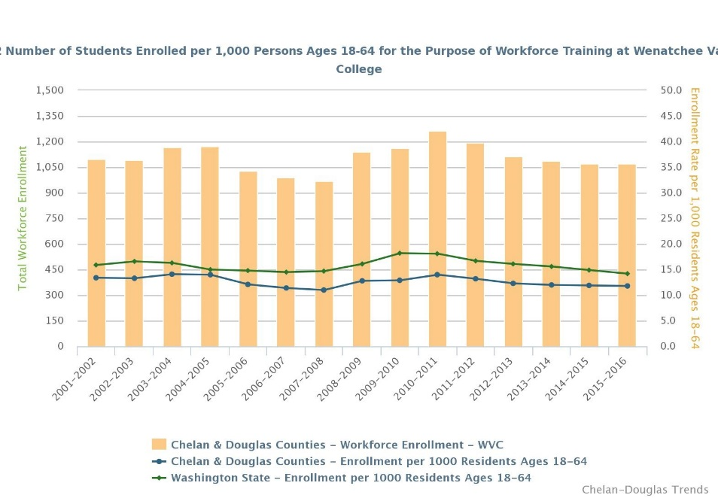
It is commonly known a highly educated workforce brings advantages to individuals, communities, and companies, but the job market has changed since the Great Recession. According to Georgetown University’s Center on Education and the Workforce, “Over 95 percent of jobs created during the recovery have gone to workers with at least some college education, while those with a high school diploma or less are being left behind… While jobs are back, they are not the same jobs lost during the recession. The Great Recession decimated low-skill blue-collar and clerical jobs, whereas the recovery added primarily high-skill managerial and professional jobs.”
This article takes a quick look at the metrics around the higher educational institution in the two-county area, Wenatchee Valley College. The Trends tracks three types of student enrollment, and these are taken up below.
The first indicator, Number of Students Enrolled at Wenatchee Valley College (WVC) per 1,000 Residents Aged 18-64 for the Purpose of Transferring to a Four-Year Institution, reveals that 2015-2016 represented the fourth consecutive academic year with declining numbers. The 1,205 enrollees at WVC with this stated purpose have increased, however, from 973, or by 24%, since the 2001-2002 school year. Another view of this group reports that 2015-2016 enrollees for this purpose at WVC per 1,000 residents of the combined counties was 13.3, increasing from 11.9 during the 2001-2002 school year. By comparison in the state during the 2015-2016 school year, enrollment for the purposes of transferring to a four-year university per 1,000 residents of the state was 11.9, decreasing from 13.7 since the 2001-2002 school year.
The second indicator, Number of Students Enrolled per 1,000 Persons Ages 18-64 for the Purpose of Workforce Training at WVC, reports a total of 1,069 enrollees in the 2015-2016 school year, decreasing from 1,096 enrollees, or by over 2% since the 2001-2002 school year. As a rate per 1,000 residents, the combined counties came in at 11.8 enrollees, decreasing from 13.4 since the 2001-2002 school year. By comparison in the state during the 2015-2016 school year, enrollment for the purposes of workforce training per 1,000 residents ages 18-64 was 14.2, decreasing from 15.9 since the 2001-2002 school year. So in contrast to the transfer student population, this segment of WVC’s enrollment falls below the Washington State average. Generally speaking, workforce training programs are designed to train or retrain the unemployed or low-wage earners to provide improved employment opportunities.
The final indicator, Number of Students Enrolled per 1,000 People Ages 18-64 for the Purpose of Basic Skills at WVC, reveals that there were 246 enrollees, increasing from 203, or by 21%, since the 2001-2002 school year. As a rate per 1,000 residents, the combined counties came in at 2.7 enrollees, increasing from 2.5 since the 2001-2002 school year. By comparison in the state during the 2015-2016 school year, enrollment for the purposes of basic skills per 1,000 residents ages 18-64 was 3.1, decreasing from 3.7 since the 2001-2002 school year. At WVC, Basic Skills training is under the Transitional Studies department and targets those seeking “personal enrichment, [completing a] high school diploma, preparing for…GED tests or transitioning to college”.
According to Dr. Jim Richardson, President of Wenatchee Valley College, “Declining enrollments since the recession have been largely driven by more students returning to the workforce, which has been shown in larger declines in enrollment for older students and students in workforce courses. While enrollment for this group of students continues to slowly decline, it appears that stagnant growth in the population of traditional, college-going students coming out of high school in our district, and more students enrolling directly in the public four-year institutions is beginning to have a larger impact on enrollment trends.”
Richardson continues “Some of the traditional out of high school enrollment seems to be replaced by dual-credit in high school enrollment. This suggests that the cost of college is central to students’ plans.”
As the recovery from the Great Recession continues, perhaps more people will be able to participate in higher education before they enter the workforce directly from high school or to supplement the experience they have already gained from years in the workforce by earning a formal education. Keeping an eye on this set of indicators in the future will perhaps provide some insight into whether this is occurring or not.
-----

5-Questions with: Frank Kuntz, Mayor City of Wenatchee
1. You are now in your second term as mayor of the City of Wenatchee. What are the major goals for your administration this term?
I am focused. Our region needs to deal with our housing crisis. A less than 1% vacancy rate creates a situation where we actually have pent up demand due to a lack of units and choice. Renters need options and this lack of housing is hurting our region’s employers who are working diligently to attract workers to great jobs including healthcare, education, research and more. We cannot begin to attract new business to our region if we do not have housing for our current population. To assist, we are working to expand our sewer system into Olds Station and Sunnyslope to encourage future housing development. Our basic city infrastructure also needs attention. Sidewalks in South Wenatchee and the overall condition of our pavement are critical issues the city is taking on during this term.
2. How will you measure success?
Increase in the Vacancy Rate. Number of days Confluence Health is on diversion. Pavement management index. New business recruitment success and local business expansion. Percentage of renters paying 30% or more for rent. Walkability score.
3. Will the Trends help inform any of this assessment?
Yes, absolutely. Chelan Douglas Trends has a number of the indicators that we will use to measure our success or failure.
4. As a native of Wenatchee, you have undoubtedly witnessed many changes in your home city. Which indicators on the Trends site reflect these changes most to you?
Vacancy rate trend is clearly one that we watch. It dropped 50% in one year. I watch regional sales tax numbers very closely now that the city is out of the fire business (annexed into Chelan County Fire District). We lost a bunch of property tax to the district and this will be reflected in our trends data. Our overall budget has been reduced but now sales tax makes up almost 50% of our budget when in the past it was about 1/3 of our budget. I also watch building permits. We need construction activity and building permits issued gives us a great indication of construction activity.
5. You have been involved in public affairs for many years in the Greater Wenatchee area. Have you noticed an increased awareness of using data in making decisions?
We talk a lot more about data than in the past. I think the data gets used as an indicator. However, I believe you still need other evidence to show you have an issue. You can say we have low vacancy rate and some people will say “so what.” You tell them that the hospital is on diversion, not because the hospital is full, but because there are no nurses to work. They ask why there are not enough nurses, and you tell them there is not enough available housing to meet their needs and the nurses move to Tri Cities or Spokane where housing is more affordable. That is a story the community will remember.

