CDT Newsletter - 2017 #1:
News from the Region:
Without the Chelan-Douglas Trends, monitoring economic development metrics progress across Chelan and Douglas counties would be a Sisyphean task for me. As the new Executive Director for the North Central Washington Economic Development District, I help our members shape a data-backed comprehensive economic development strategy, and report regularly to our funders and other stakeholders on outcomes in our region. The diversity of data indicators monitored by the Trends team are proving to be a vital resource both for my reporting responsibilities AND for supporting strategic planning among our members.
Karen Francis-McWhite - Executive Director, North Central Washington Economic Development District

Indicator News:
Hans Rosling - The Best Stats Visualization You’ve Ever Seen
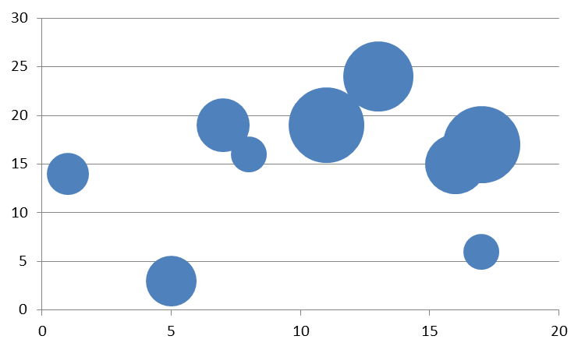
Times are changing - you don’t have to be a complete data geek to enjoy data. With new visualizations and a variety of ways to compare data, it sometimes seems like new data presentations are appearing daily - some good and some not-so good.
On the good side, Hans Rosling, has a unique way of how he wants us to look at data. As a professor at the Karolinska Institute in Stockholm, Sweden, he realized that there was “broad ignorance about the rapid health improvement in Asia” and in response, developed a tongue-in-cheek “Chimpanzee Test” as part of The Ignorance Project.
Expanding on the concept of simplifying data presentations and visualizations to help people better understand what data is trying to say, Rosling produced his first of many videos, titled The Best Stats You’ve Ever Seen.
Using animated bubble graphs, Rosling shows just how interconnected data can be. The bubble graph Rosling uses in the video has been updated, is fully interactive, and is accessible through the Gapminder website here. For example, you can watch the life expectancy for every nation in the world drop during WWI and the income per person in most countries in the world drop during the Great Depression of the 1930’s.
By clicking on the line titled “Income per person, GDP/capita in $/year adjusted for inflation & prices”, many different types of data can be viewed with the same animated and interactive aspects. If you are not quite there yet, we hope Rosling and the Skagit County Trends website are helping you become a full-fledged data geek!
Blue Cross Blue Shield Health Index
According to Blue Cross Blue Shield (BCBS), the “Health Index was designed to support national and local discussions about how to improve American health policy and practice. It is part of Blue Cross and Blue Shield companies’ commitment to improving the health of America by uniting policymakers, community leaders, healthcare professionals and business leaders around data-driven insights to spark real change. It provides a better understanding about which diseases and conditions most greatly affect Americans’ overall quality of life.”
Using internally generated data from more than 40 million BCBS members, the “first-of-its-kind resource identifies the health conditions with the greatest impact on commercially-insured Americans.” Including over 200 common diseases and conditions, the Health Index offers a score between 0 and 1 for nearly every county in the U.S.
The score represents the percentage of optimal health that the county is living at. For example, “a measurement of .9 indicates that, on average, the population of a county is living at 90% of its optimal health.” The BCBS Health Index for the nation is .924, meaning America is living at 92.4% of our optimal health.
Chelan County has a BCBS Health Index score of .937, meaning the county is living at 93.7% of its optimal health. Douglas County posted a score of .932.
In the rest of Washington State, BCBS Health Index scores range from a high of .947 in Adams County to a low of .904 in Wahkiakum County. Nationally, scores range from a high of .966 (Grant County, Nebraska) to a low of .867 (both Bland County, Virginia and Charlotte County, Florida).

Washington Tracking Network (WTN) - Local Public Health Data
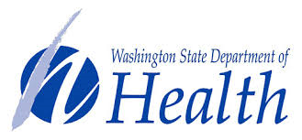
“The Washington Tracking Network (WTN) is a public website where users can find data and information about environmental health hazards, population characteristics, and health outcomes.”
Subtitled as “A Source for Environmental Public Health Data”, the website is supported by a Cooperative Agreement, the Washington State Department of Health provides the content of the (WTN) website.
The WTN website is a multi-layered, interactive website. Users can access WTN quick information by subject, through the portal, or by using the Information by Location feature.
The first section, information by subject, offers a list of health-related subjects listed on the left-hand side of the webpage. Subjects include (but are not limited to): Asthma, Drinking Water, Heat Stress, Lead Exposure, Pesticides, Radon, and Traffic Air Pollution. Each subject offers important background information, some quick stats, and additional links to learn more about the subject and ways to reduce some of the negative effects.
The second section, the Portal, includes the following main category data topics: Climate and Health, Community, Environment, Exposure, Health, and Local Public Health Indicators (LPHI). Although the topics have varying geographical data available (some contain only state data while others offer census tract data), the LPHI indicators offer comparable data for each county in the state.
The third section, the Information by Location feature, which provides a map of Washington State and is offered at U.S. Census tract level. Four main categories include: Health Disparities, Lead Exposure, Social Vulnerability to Hazards, and Planning for Health.
Combined, the Washington State Department of Health Washington Tracking Network provides unique insight and perspectives of the state of health in Washington State.

Indicators in Action:

Local Levy Revenue Generated per Full Time Equivalent Pupil by Scott Richter and Dr. Patrick Jones
Levy revenue is the portion of public school funding that comes from local tax revenue. In addition to local sources, public education is financed through state, federal and other sources in the State of Washington. Increases in revenue over time are beneficial to a community, given the well documented relationship between education and positive outcomes as young people become adults. This indicator highlights the degree to which local residents are willing and able to support public education in the form of local taxes relative to their collective economic status.
According to Cindy Ulrich CPA, Executive Director of Finance with the Eastmont School District, “While the majority of a school district’s operating revenue is provided through the State of Washington (68%), this funding is not enough to cover the costs of the program Basic Education so school districts use local levies as a resource.” Based on property values, the dollars generated by local school levies varies across the state, as Ulrich puts it, differences resulting from “property rich” and “property poor” areas.
Brian Flones, Superintendent for Wenatchee Public Schools, says compared to “property values and income levels are lower in Chelan & Douglas Counties, and in Eastern Washington rural communities, resulting in a higher percentage of income for an even lower levy revenue per pupil.”
Examining the Levy Revenue Generated per Full Time Equivalent (FTE) Pupil and Total Levy Revenue Generated as a Percent of Total Personal Income (TPI) indicator, it is quickly apparent the combined counties are below the state for the levy revenue generated per FTE public school student.
During the 2014-2015 school year, the levy revenue per full-time equivalent (FTE) students in Chelan & Douglas Counties combined was $1,604, increasing from $829, or by 83%, since the 2001-2002 school year. During the same year, Washington State levy revenue per full-time equivalent (FTE) students was $2,122, increasing from $1,097, or by 93%, since the 2001-2002 school year. The Washington State benchmark represents local levy revenues generated across the state and does not include levy revenues generated by the state that are dispersed to local school districts.
However, when examining the levy revenue generated as a percent of Total Personal Income (TPI), which is defined as the total of all income from all sources, we see that the combined counties have consistently generated more levy revenue as a share of their TPI compared to the average local levy revenue generated within in the state.
Flones says “Most districts on the west side of the state max out their levy equalization capacity at 24% or 28% with a much lower levy rate per thousand than rural school districts in Eastern Washington. Our school district uses 14.9% of our 28% capacity. We could generate 6.4 million dollars more in levy revenue if we used our 28% capacity but that is not realistic with what our communities will support with the current tax rates.
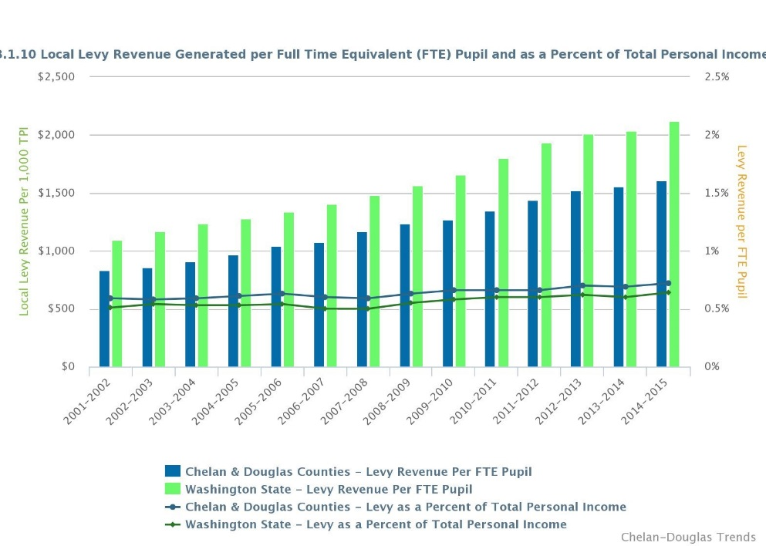
Ulrich explains “levy revenue generated as a share of total personal income in [Chelan and Douglas Counties] would be higher when compared to the state because personal income in our region is much less than the state average.”
Looking at each of the individual counties, we can see that the levy revenue generated in Chelan County very closely follows the combined counties’ trend line. Beginning during the 2010-2011 school year, Douglas County has slowly moved ahead of the combined counties benchmark. By the 2014-2015 school year, in Douglas County all district school levies equaled 0.81% of the TPI in the county, compared to 0.72% in the combined counties.
It is important to note that due to OSPI's Accountability Rules, Institutional, Tribal, Reengagement and Alternative Schools with greater than 50% of their enrollment from outside of their district are not included in school district level data. As a result, some schools districts have high schools that aren't being computed in the district level estimates, but are being counted in the county level estimates.
Ulrich explains how “Maintenance & Operation levies, now more commonly referred to as Educational Program levies, are a critical source of operational revenue for public schools in each of these counties…[and] this type of levy is necessary in order to make up the difference between what is costs to provide Basic Education and what funding is received from the State of Washington.”
Flones says the state is making up the difference between the local levy revenue generated and general fund expenditures. “Wenatchee receives around 4 million additional dollars from the state.”
Ulrich also explains “Eastmont School District has found success with our community by utilizing transparent reporting to communicate use of tax dollars. We believe this has been critical in generating support from the community for renewed 4 year levies.”
It is likely that the trends displayed in this indicator, both for the local levy revenue generated per full-time equivalent student and the percent of total personal income accounted for by local levies, shouldn’t see very drastic changes in the future. Instead, the per pupil revenue generation in the combined counties should stay below the state benchmark, while the percent of TPI should stay above the state benchmark.

--------------------

Residential Building Permits Issued Recovering Slowly by Scott Richter and Dr. Patrick Jones
Residential building permits compose an important subset of total construction permits, and consequently an important activity in any economy. An increase in the number of residential building permits reflects an increase in population growth or a desire by current residents to change their dwelling, usually the most important financial asset of a family or household.
As in the case of general construction, changes in the quantity of these permits signal the direction of near-term activity to the construction trades and real estate industry. The direction of building permit trends also informs local government about future sales tax revenues, since residential building leads to taxable sales in a variety of sectors.
Examining the Total Number of Residential Building Permits and Number per 1,000 Residents indicator, it is one of the many indicators on the trends site where we can see clearly the effects of the start of the Great Recession, the subsequent down years, and the recovery years. 2007 represents the highest number of residential building permits issues in the combined counties (1,107). The 2nd and 3rd highest number of residential building permits in the series took place in 2005 and 2006 (902 and 1,041 respectively). These numbers represent the total estimated residential building permits issued for all jurisdictions within the combined counties.
The four years producing the lowest number of building permits tracked in the series, 2009, 2010, 2011, and 2012 are the years reflecting the downturn caused by the Great Depression. 2013 produced the 4th highest number of residential building permits issued in the combined counties for the entire series at 706, but 2014 and 2015 numbers fell short of the 2013 numbers (460 and 593 respectively).
According to Lori Barnett, Community Development Director for the City of East Wenatchee, “With regards to the trends, we are seeing growth in the multifamily housing sector. That is a direct result of a rental shortage. It is now advantageous for developers to build apartments. They fill up as soon as they are finished.”
An examination the state and U.S. benchmarks, which track the number of residential building permits issued per 1,000 residents for each of the jurisdictions, reveal that the results for the combined counties over the last six years have generally been between the state and U.S. figures. Most recently during 2015, the rate of residential building permits issued per 1,000 residents of the U.S. was 3.69, of the state was 5.72, and of the combined counties was 5.16.
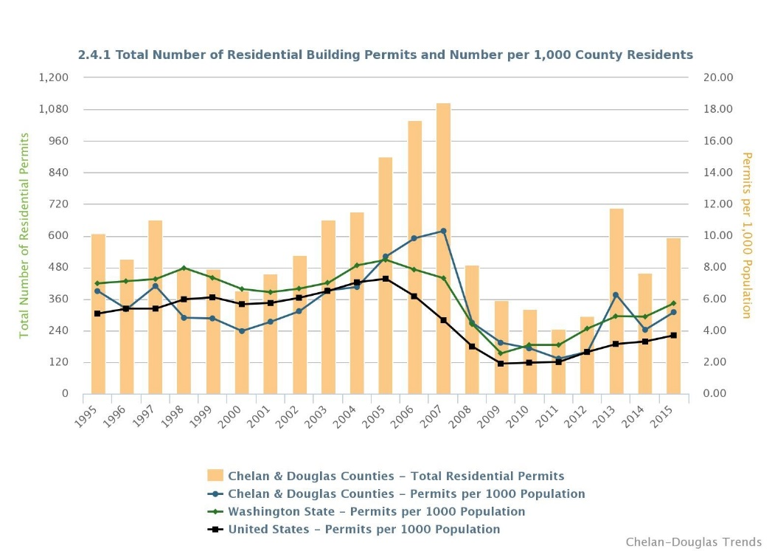
Similar trends appear in the number of residential building permits issues in individual counties. The main difference between the two is the spike in the total number of residential building permits issued in Chelan County during 2013. We don’t see a similar trend for Douglas County during 2013. These numbers represent the total estimated residential building permits issued for all jurisdictions within each individual county.
Barnett says “It is unlikely that we will see much growth in residential permit activity within the City [of East Wenatchee] - certainly nothing like we experienced in the period 1996 through 2007. We are running out of large tracts of vacant land within the city limits. Most of the vacant land is in Douglas County and that is where are the platting is taking place.”
As a result, there is only so much growth we can expect to see in this indicator in the future. Barnett says any growth that does occur “will be nothing like we experienced in the period 1996 through 2007.” Growth in multi-housing permits is due primarily to developers meeting the housing market demand and cannot continue indefinitely. But perhaps the most positive aspect of this indicator is the upswing in the last few years since the Great Depression. Historical numbers may not be achieved, but recovery and small growth is still a positive economic sign.

--------------------

Population Density in Wenatchee & East Wenatchee Higher than Benchmarks by Lena Negrete, Scott Richter, and Dr. Patrick Jones
Population density goes hand in hand with population growth. Population density is one way to measure where growth occurs. Here, it is expressed as the number of people per square mile in Chelan and Douglas Counties and for the Cities of Wenatchee and East Wenatchee.
In urban settings, minimum population density requirements must be met to financially support urban services, such as public transit, grocery stores, and other commercial amenities. However, without complementary land use planning, minimum population density goals will not guarantee smart growth.
The indicator for the Number of People per Square Mile of Land offers the cities of Wenatchee and East Wenatchee in separate graphs, although the benchmarks provided are the same for each city.
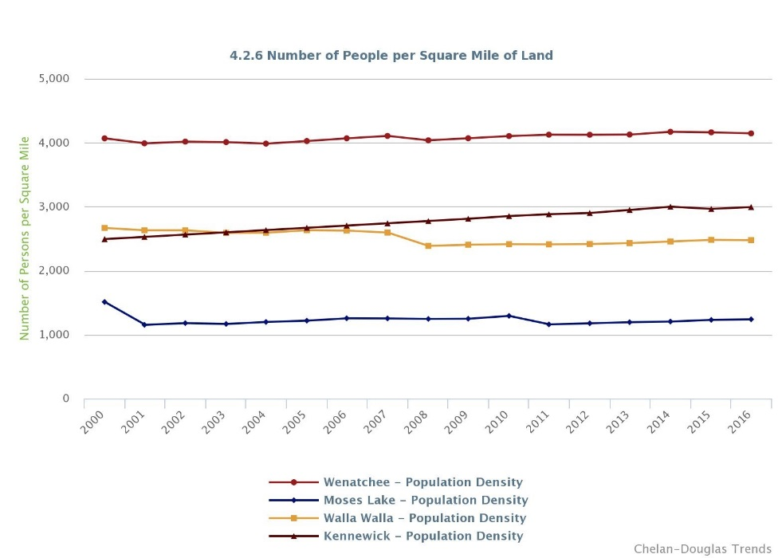
Looking at the City of Wenatchee, we see that the trend line consistently hovers close to 4,000 people per square mile of land, much higher than the benchmark locations for the cities of Moses Lake, Walla Walla, and Kennewick. The path of population density growth of Wenatchee (increased from 4,068 people per mile during 2000 and 4,146 in 2016 can be characterized as flat, with an increase from 4,068 people per mile in 2000 to 4,146 in 2016, or a +1.92% rise. Density in East Wenatchee has increased at a much higher rate - 2,704 in 2000 to 3,676 in 2016, or 35.95% rise.
Richard Brinkman, a former employee for the City of Wenatchee and current Sociology professor at Wenatchee Valley College, says the City of East Wenatchee has always been somewhat of a “sleeping giant”. The abundance of land beyond the city limits has always been there. Brinkman explains population density has always been much lower in East Wenatchee than that of Wenatchee, yet comparatively, the potential for growth remains on the East Wenatchee side of the river.
The City of East Wenatchee saw two major jumps in 2001 and 2006, which can be traced back to two different land annexations. According to Brinkman, these land annexations allowed the city to collect tax revenue from two major retailers located in East Wenatchee; Costco Wholesale and Hometown Auto Group.
According to Jeff Wilkens, Executive Director for the Chelan-Douglas Transportation Council, available land suitable to build on within the Wenatchee city limits is running low. Wilkens said, the available land suitable to build on are not large parcels of land, but tiny pockets. As a result, “The basic story here is that Wenatchee will transition to smaller scale redevelopment as vacant land becomes increasingly scarce.”
Wilkens also notes that one of the limitations of the data behind this indicator is it doesn’t distinguish between types of designated land zoning within city limits. For example, a city could be densely populated but also have large tracts of land zoned for industrial purposes, which basically offsets in the real changes in the population density.
Brinkman believes the populations of Wenatchee and East Wenatchee have continued to slowly grow as opposed to dropping due to the Alcoa plant closure is in large part due to the retraining opportunity at the college, funded by the U.S .Trade Adjustment Assistance Act. This worker retraining program has provided many former Alcoa workers with educational and career planning opportunities in a vocational field allowing them to return to work and continue living in the area.

--------------------

5-Questions with:
Linda Evans Parlette, Executive Director North Central Accountable Community of Health, Chelan-Douglas Health District
And Barry Kling, Administrator and Director of Environmental Health, Chelan-Douglas Health District
1. You have been in the role of the Executive Director of the North Central Washington Accountable Community of Health (ACH) for a few months now. What are the organization’s plans for 2017?
Linda: I accepted the job as Executive Director in July 2016 but chose not to take a salary until my term as the State Senator for the 12th legislative district ended in January, 2017. Our early focus in 2017 has been to focus on our governing structure—filling in our Board, completing our by-laws, and preparing, as all ACHs are, to become certified. Certification is a two phase process with Phase One being completed in May and Phase Two in August. The details from the state will be forthcoming.
The state’s application to the federal government for an 1115 Medicaid Waiver was accepted by CMS on January 11, 2017. It is now called a Demonstration project. Each ACH is required to do two projects that are the same, all across the state, and then choose up to six projects on an optional list with a minimum of two required. Our ACH is in the process now of reaching out to our community stakeholders in Chelan, Douglas, Grant, and Okanogan, and sharing with them what the option projects are while seeking their input at the same time.
The optional projects have to be the same across all four counties. The Project Application Template will be available in July with the final project plans due in October, 2017. We have a tremendous amount of work to do between March and October and the need for accurate data is key.

2. The ACH undoubtedly needs to respond to many data needs. Can you tell us what some of the likely areas of measurement that you will engage in?
Barry: Our biggest responsibility will be to measure the impact of the projects we implement under the Medicaid 1115 Demonstration to improve the care of Medicaid patients while controlling per-capita health care costs. We’re in the process of selecting these projects now. The Demonstration allows our state to use $1.5Billion over 5 years to improve Medicaid in ways that pay for themselves and are self-sustaining at the end of that period. We will get a share of that funding in our region. Measuring the impact of those projects is a real challenge, and we’ll depend to large degree on state Medicaid data sets and performance metrics. But we will also be looking at regional benefits such as prevention of unnecessary ER visits and hospitalizations. Another important area of measurement has to do with the fact that many of the forces influencing health happen outside the walls of clinics – for example, a person with diabetes who is homeless is not likely to do much about diabetes until he or she has a place to live. So we will also be working to enable health care providers to more effectively connect of patients with community resources (such as social service agencies) that can help them deal with the social determinants of health (that is, those outside-the-clinic social issues with important health effects). We will also be working on the integration of behavioral health care with physical health care, because we know that works better for patients, and will want to measure the effectiveness of that effort. Finally, an important issue for us is to sustain the viability of provider organizations in the region, especially in our most rural areas. We don’t have enough providers there now, and we can hardly afford to lose any.

3. Chelan Douglas Trends covers many annual health and socio-economic indicators relevant for health outcomes for two of the counties in the ACH, at least. Which ones will be the most helpful to your work?
Barry: One of our biggest challenges is getting close-to-real-time data so that we can tell how we’re doing sooner than two years after we do something. The Trends site does a good job of using the most recent information, but it’s a challenge for statewide and regional data. We will be measuring our ACH work over the next 4 ½ years, so that involves relatively short-term impacts (such as rates of ER admission, or success in controlling blood glucose levels among Medicaid patients with diabetes). Many of the things reflected in the trends data are longer-term outcomes such as cause of death or infant mortality. They’re very useful reflections of community health and related factors, but aren’t designed to work as evaluation measures for our projects. There is a set of 60 measures that will be used to evaluate our projects, many related to care issues such as the frequency of appropriate well-baby visits, but some related to larger social factors such as rates of inappropriate opioid use.

4. As you look across the board at all the indicators on the Trends site, are there any surprises?
Barry: Well I may be the wrong person to ask about surprises, because one of our roles in public health is to be looking at information like this on a regular basis. So it would take a really radical change to surprise me at this point! But I do have a few thoughts to share on what ought to be surprising to our community.
One item is the fact that our youth and adult obesity rates track pretty well with the State’s and the Nation’s – and that’s not good. Since the 1990s rates of obesity in this country have roughly tripled, which is a truly incredible increase in a relatively short period. You just don’t normally see such massive rapid changes in a basic health indicator. And it has consequences. Children in the United States today are at risk of having shorter life expectancies than their parents’ generation – for the first time in modern US history. We are also about to see a tsunami of diabetes and preventable heart disease as a consequence of the obesity epidemic. A lot of factors seem to have created this problem, but it is difficult to overstate its importance.
We also have an unusually high rate of teen pregnancy in our area in recent years – and we know this causes serious problems for many of the moms and babies involved. Yet the services we can provide to these vulnerable families have been gutted over the past decade by reductions in funding – in spite of strong research evidence that these services save more money than they cost and have major health benefits over many years.
The opioid epidemic is certainly affecting our area, as in most parts of the state. This requires several different responses, ranging from better availability of overdose treatment to attitude changes. Opioid addiction, once it occurs, is a brain disease that can be successfully treated. We should no more withhold treatments for opioid addiction than we would tell a diabetes patient to tough it out as we take away their insulin. As you can see, our attitudes are as important as our medicines and our programs in addressing this problem. And by the way – opioids are the current hot topic but these points apply to other forms of addition, too.

5. You are a long-time resident and a former 20-year veteran of the Washington state legislature. In the course of your time serving the public, have you noticed an increased awareness of and willingness to use sound data for decision-making?
Linda: I had the good fortune to be selected to serve on the House Appropriations Committee for my 4 years in the House of Representatives and later serve for 16 years on the Washington State Senate Ways and Means committee.
Good sound data is needed not only for policy committees but also budget committees; I learned early on that they way you ask the question can give you different information results. I also learned that data results can vary if not presented in an “evidence based” manner. In my first term as a legislator, Washington State did not have an actuary. Later one was hired and that had a positive impact on the data available for the state. I appreciate now that there is an increased awareness for sound data for decision making.

